**What to expect when you come to MacEwan University Health Centre**

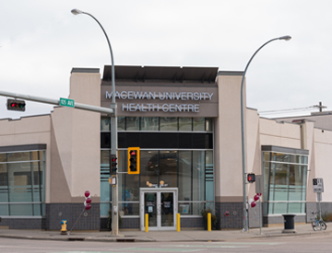

MacEwan University Health Centre is located at 10507 – 109 Street, Edmonton, AB T5H 3B1.

The front entrance is on the N.E. corner of 109 Street and 105 Avenue.

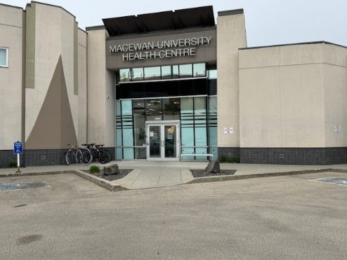

The back entrance is located adjacent to the parking lot at the north of the building and can be accessed from 109 Street or 105 Avenue

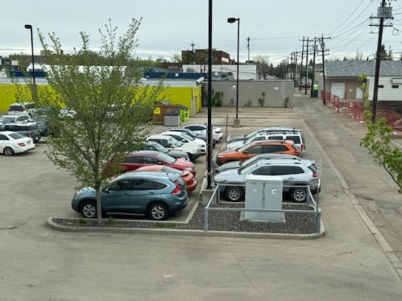

Patient parking is located adjacent to the back door of the clinic. This can be accessed from 109 Street or 105 Avenue.

Once parked, make a note of your license plate. You will enter this into the parking meter in reception to receive free parking.

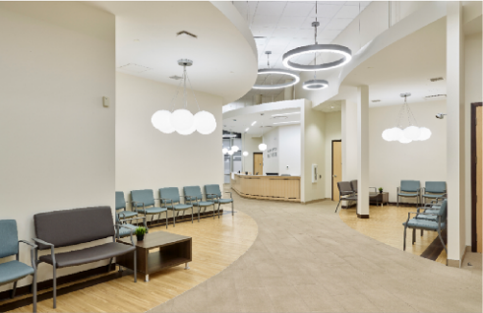

The Reception Desk and waiting room can be accessed from  
both the front and back doors.

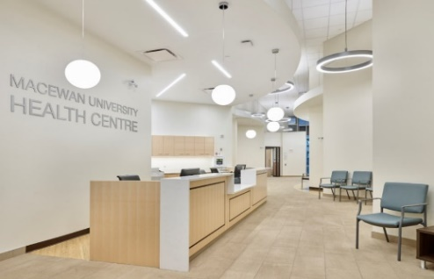Once you arrive in reception you will need to check in with one  
of the receptionists. If you parked in the parking lot they will show you how to register your license plate number to receive free parking.

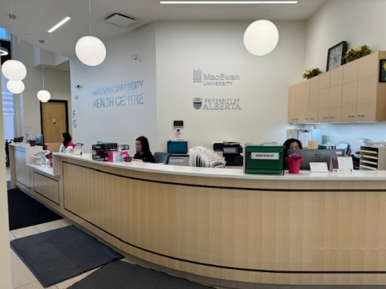 The Receptionist will ask you the following questions:

* Your name
* Your appointment time
* Which physician you are seeing
* They will confirm your address and phone number we have are correct
* They will ask if you have any respiratory symptoms
* Then you will be asked to sit in the waiting area designated to your physician

When you check in you might be given a form to complete.

* Intake forms if you are a new patient
* Pre-Physical Questionnaire if you are having a Complete Physical

**The MacEwan University Health Centre is sensory friendly. We aim to offer a safe and welcoming space for all. If, at any time during your visit with us you are overwhelmed by bright lights, noise or activity please inform one of the staff. Our clinic has dimmable lights, ear plugs and fidget aids available.**

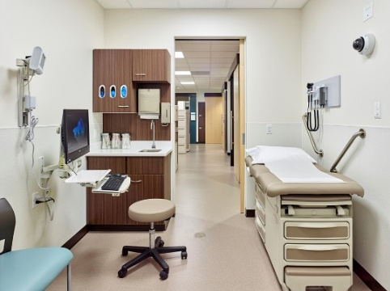In preparation for the physician to be ready to see you the  
assistant will approach you in the reception area and call your name. If there is someone you would like to accompany you, please feel free to bring them. You will be taken into the patient corridor. The assistant may or may not need to get your height, weight or visual acuity.

The assistant will show you into the exam room. Please ask if   
 if you would like the lights to be dimmed. The assistant may or   
 may not take your temperature, blood pressure or check your  
 oxygen saturation.

You are able to decline any of these tests if you so wish.  
  
While you are waiting for your physician you may walk  
around in the exam room and touch things in the room, but please do not open the cupboards. Please feel free to use your phone or other devices in the exam room.